Franz Seraph von Stirnbrand
Jana Cornelius
2023-04-28
Table of contents

1. Franz Seraph von Stirnbrand
Author: Cornelius, Jana Lisa
ORCID: https://orcid.org/0009-0004-3404-2441
Date: 28.04.2023
DOI: 10.5281/zenodo.7852387
Repository URL: https://github.com/Janacnl/catalogue-003
2023-03-17
Book cover: Reworking of Jahrhundertausstellung 1906 KatNr. 1727). Creative Commons CC0 1.0 Universal Public Domain Dedication.

This work is licensed under a Creative Commons Attribution-ShareAlike 4.0 International License.

2. Colophon
- Fork title: Janacnl / catalogue-003
- Author: Cornelius, Jana Lisa
- ORCID: https://orcid.org/0009-0004-3404-2441
- Date: 28.04.2023
- DOI: 10.5281/zenodo.7852387
- Repository URL: https://github.com/Janacnl/catalogue-003
PUBLISHING FROM COLLECTIONS USES OF COMPUTATIONAL PUBLISHIGN AND LINKEDOPEN DATA
Open Science Lab - TIB Hannnover
First published 2023-03-30
Copyright © The Authors 2023 Licensed as https://creativecommons.org/licenses/by-sa/4.0/
DOI: https://doi.org/10.5281/zenodo.7701161

3. About the Painter
- Jana Cornelius

3.1 Franz Seraph von Stirnbrad: A Master of Emotive Brushstrokes
Franz Seraph von Stirnbrad (1798-1832) was a renowned painter known for his ability to infuse his works with deep emotion. His dynamic and expressive brushstrokes captured the essence of the human experience, from joy and serenity to sorrow and anguish. Stirnbrad’s paintings resonated with viewers on a profound level, evoking introspection and empathy.
One of Stirnbrad’s notable works is “The Weary Wanderer,” portraying a figure walking through a desolate landscape, conveying exhaustion and despair. Another masterpiece, “The Dance of Elation,” captures the vibrant energy of a joyous celebration with bold colors and dynamic brushwork. Stirnbrad’s style, influenced by the Romantic movement, showcased his unique approach, characterized by fluid and intense brushstrokes.
Despite his premature death at 34, Stirnbrad’s artistic legacy lives on. His paintings can be found in museums worldwide, captivating and inspiring audiences with their ability to convey emotion. Franz Seraph von Stirnbrad’s work is a testament to the power of art in capturing the complexities of the human experience and leaving a lasting impression on all who encounter it.
ChatGPT (2023): Stirnbrad. Emotive Brushstrokes. Online unter https://chat.openai.com/share/6e313857-9a53-4de0-b661-b5c98692fd5a [Abruf am 14.06.2023]

4. Data Visualizatzion
- Jana Cornelius

4.1 Data visualized using Palladio
#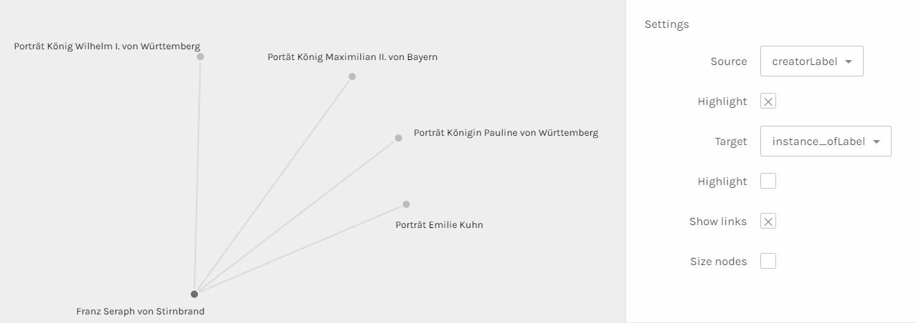

5. Paintings catalogue

5.1 Portät König Maximilian II. von Bayern
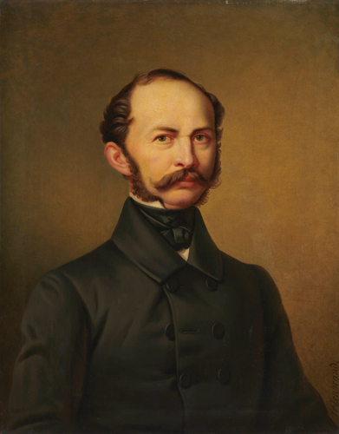
Depicts: Maximilian II of Bavaria
Year: 1860
Creator: Franz Seraph von Stirnbrand
Copyright: public domain
Wikidata link: http://www.wikidata.org/entity/Q119228942

5.2 Porträt Königin Pauline von Württemberg
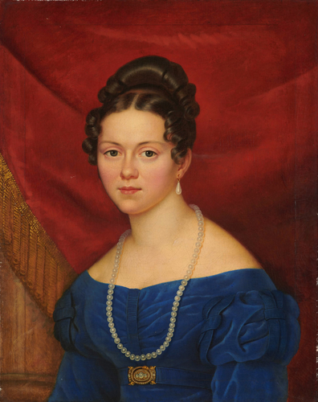
Depicts: Pauline Therese of Württemberg
Year: 1822
Creator: Franz Seraph von Stirnbrand
Copyright: public domain
Wikidata link: http://www.wikidata.org/entity/Q119230131

5.3 Porträt Emilie Kuhn
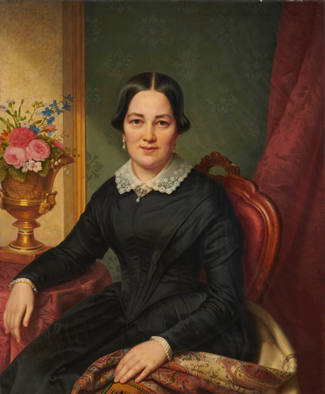
Depicts: Emilie Kuhn
Year: 1842
Creator: Franz Seraph von Stirnbrand
Copyright: public domain
Wikidata link: http://www.wikidata.org/entity/Q119230133

5.4 Porträt Emilie Kuhn
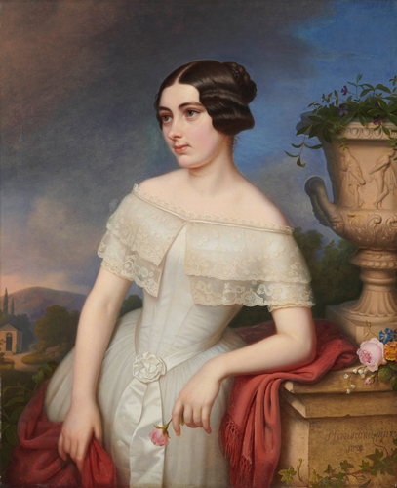
Depicts: Emilie Kuhn
Year: 1849
Creator: Franz Seraph von Stirnbrand
Copyright: public domain
Wikidata link: http://www.wikidata.org/entity/Q119230135

5.5 Porträt König Wilhelm I. von Württemberg
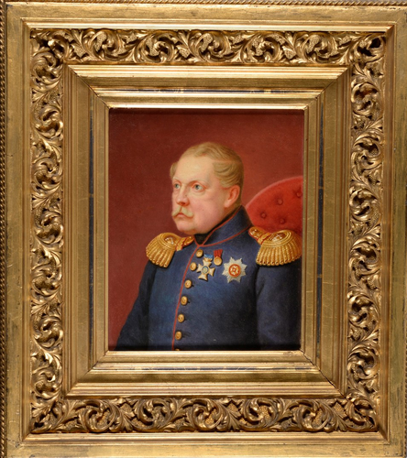
Depicts: Wilhelm I of Württemberg
Year: 1859
Creator: Franz Seraph von Stirnbrand
Copyright: public domain
Wikidata link: http://www.wikidata.org/entity/Q119230137

5.6 Porträt König Wilhelm I. von Württemberg
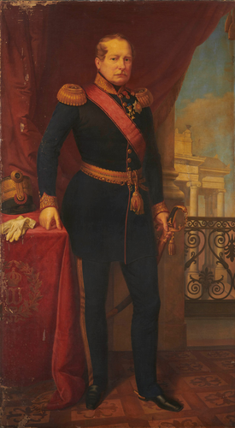
Depicts: Wilhelm I of Württemberg
Year: 1841
Creator: Franz Seraph von Stirnbrand
Copyright: public domain
Wikidata link: http://www.wikidata.org/entity/Q119230139

